# Name : Soumya Vinod Mudalgi

**Roll No:24 Experiment no: 12**

# Implement java programs based on exception handling using try-catch, finally, throw and throws keyword.

## Code:

class demo

{

public static void main(String args[])

{

//ArithmeticException try{

int a,b,c; a=10; b=0;

c=a/b;

System.out.println(c);

}

catch(Exception e){ System.out.println(e);

}

//finallyException finally {

System.out.println(

"finally : i execute always.");

}

//array index out of bound E try{

int b[]=new int[2]; b[5]=5;

System.out.println(b[5]);

}

catch(Exception e)

{

System.out.println(e);

}

//number format exception try{

int a= Integer.parseInt("dfd");

}

catch(Exception e)

{

System.out.println("numberformatexception");

}

}

}

## Output:

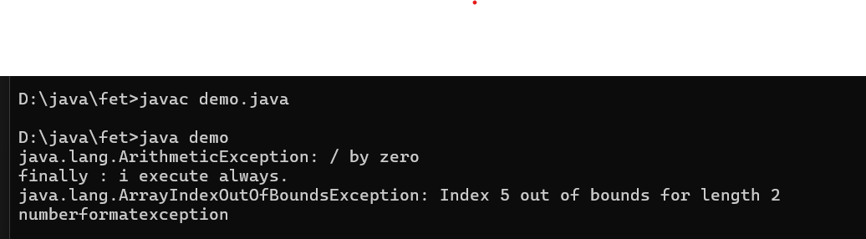

**Code:**

import java.util.Scanner; class age

{

public static void main(String args[])

{

System.out.println("enter the age:"); Scanner s=new Scanner(System.in); int a=s.nextInt();

if(a<=18)

{

throw new ArithmeticException("person is not elgible for vote");

}

else

{

System.out.println("person is elgible for vote");

}

}

}

## Output:

